MA 322 (2021) Scientific Computing Lab Lab 08

**Name:** Udandarao Sai Sandeep

**Roll Number:** 180123063

**Dept.:** Mathematics and Computing

**Note:** Install pretty table module before running the code.

**Q1.**

The **BVP** is as follows:

$$\frac{d^{2}y}{dx^{2}}+y\left(x\right)=1+x, y\left(0\right)=y\left(\frac{π}{2}\right)=0$$

The **exact** **solution** is as follows:

$$y\left(x\right)=1+x-\cos{x}-\left(1+\frac{π}{2}\right)\sin{x}$$

Here, we have taken **h** as $\frac{π}{4},\frac{π}{8},\frac{π}{16},\frac{π}{32},and \frac{π}{64}.$ And, the **f.d. solution** has been evaluated at **x= $π/4$**. This had to be done because boundary value of x is dependent on $π$.

The values have been estimated using second order scheme.

Here, we have defined the **ratio of error** = $\frac{e_{i}}{e_{i-1}}$ **= $\frac{Current Error}{Previous Error }$**

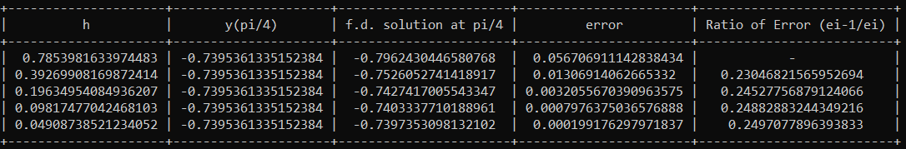

Here, we can see that **ratio of error** converges to a certain value, as **h** decreases.

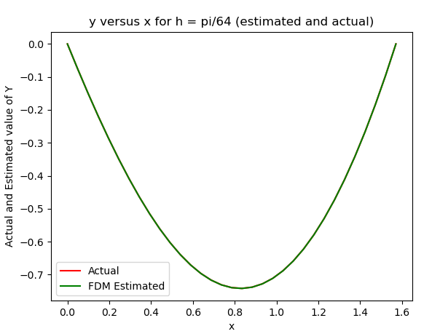

Here, for h = $\frac{π}{64},$ the estimated value and the actual value of the solution has been plotted out. The error between the plots is so small that they seem to be the same curve in the adjoining figure. In the plot given on the next page, we can see that the error is minimal.

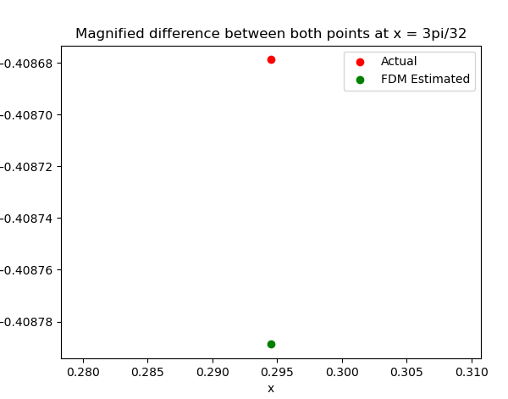

The adjoining graph displays the estimated and the Actual value at x= $\frac{3π}{32}$. The error is very insignificant.

**Q2.**

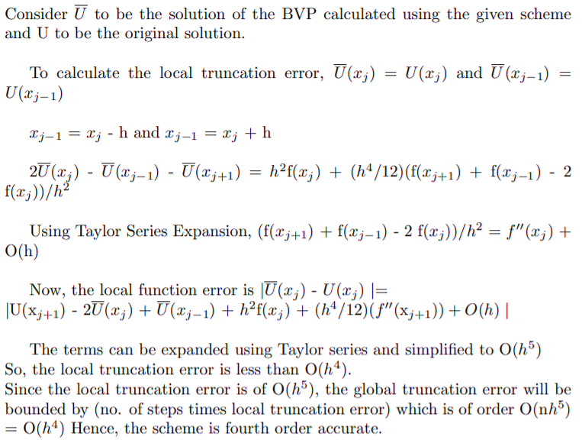

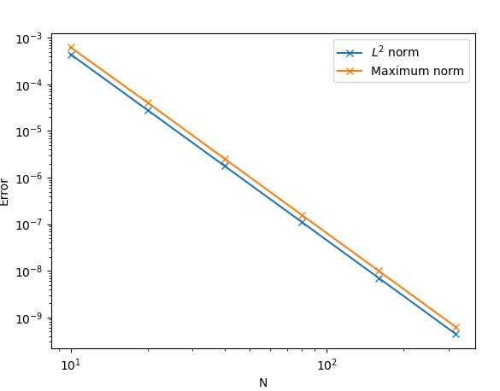

Log

Error

log

Now, we solve the **BVP** using the given scheme and compare the discrete **L2** **norm** and the **Linf** **norm** of the obtained solution w.r.t the known solution **u(x) = sin(x)**. The errors in each case have been plotted in the above graph.

We can verify the fourth order accuracy of the scheme by seeing that the **log error** vs **log N** graph has slope **-4** (approximately). This shows that the error is of the order **n-4**, i.e., **h4**. Moreover, the **L2** norm is lesser than the **Linf**norm as expected.

**Note:** Nodal estimated values (for different values of n) has been provided in the Solution File.

**Q3.**

**BVP:**

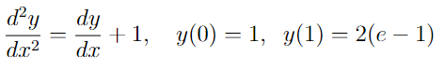

**Exact Solution:**



Using second order scheme, the absolute error at the nodal points have been calculated. The results are as follows:

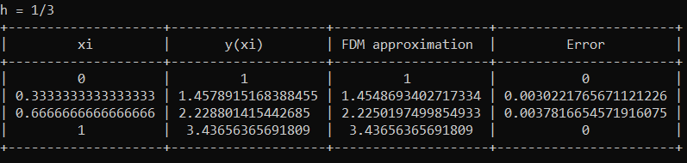

**Q4.** h has been set to **0.25**. Symmetric difference approximation was applied to $\frac{d^{2}y}{dx^{2}}.$

Central difference approximation, Backward difference approximation and Forward difference approximation was applied to **dy/dx**.

The results are as follows:

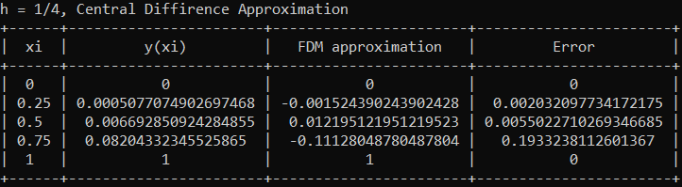

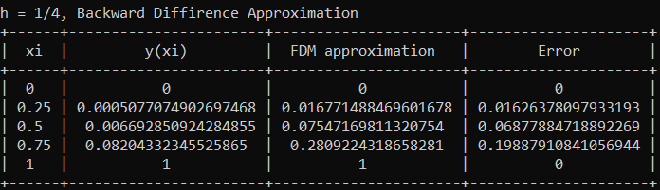

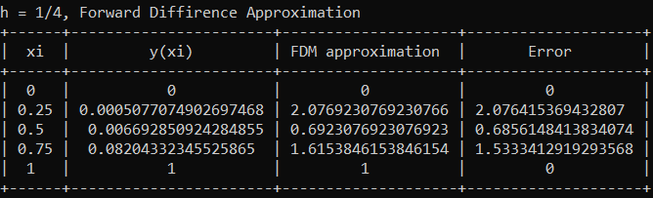

**Comparison of Errors:**

